**Project Title: Preganancy prediction**

**Name: Rethinagiri G**

**Roll no : 225229130**

**Project summary:**

This project aims to analyze the factors that influence pregnancy outcomes using a dataset containing information about pregnancies and their outcomes

**Dataset description:**

The pregnancy dataset contains eight features, including a unique identifier for each pregnancy case, birth weight of the baby in grams, length of gestation in weeks, number of previous pregnancies the mother has had, age of the mother in years, height of the mother in inches, weight of the mother in pounds, and a binary variable indicating whether or not the mother smoked during pregnancy.

**Block Diagram:**

**Module descriptions:**

The project will use various modules such as data cleaning, exploratory data analysis, statistical analysis, and machine learning

**Screen shots with explanations:**

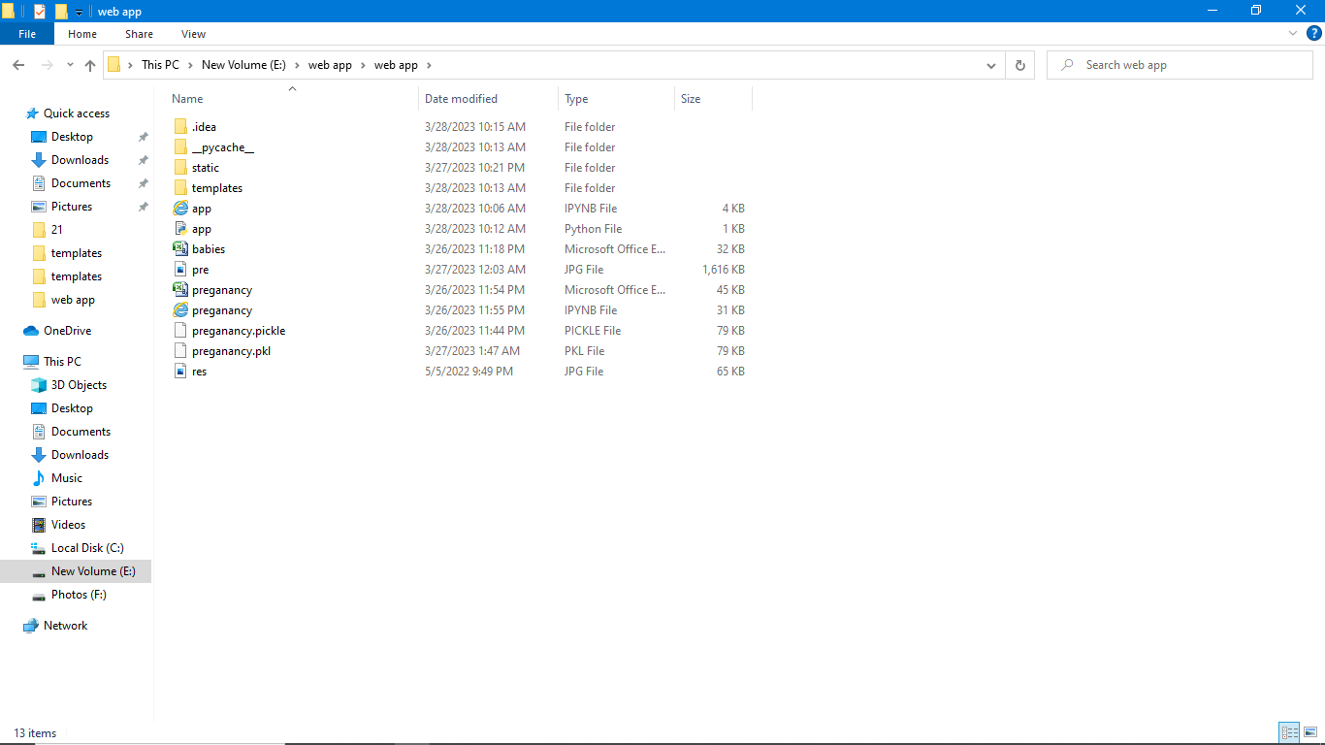 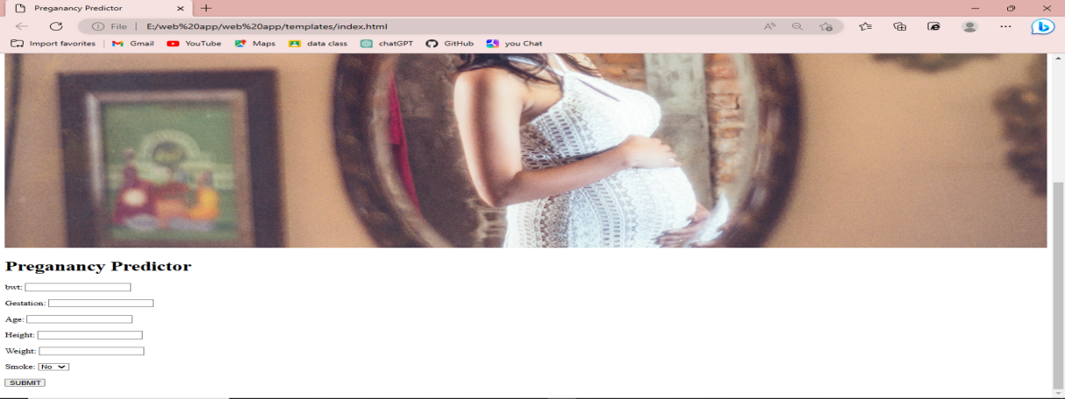 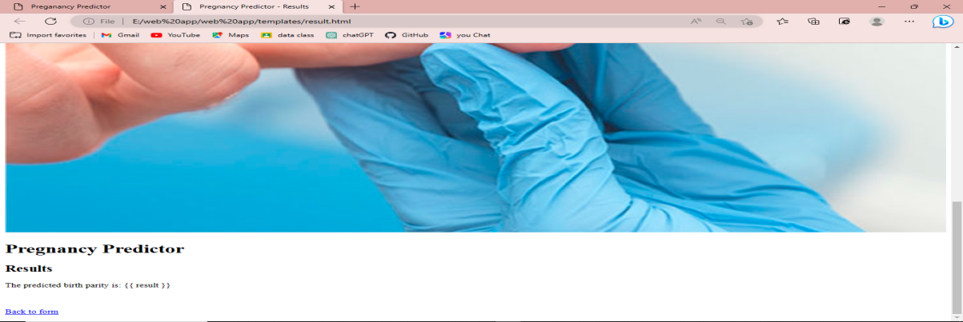

**URL of the Web App:**

[**http://127.0.0.1:5000/**](http://127.0.0.1:5000/)

**Installation and Usage Details:**

Pandas,scikit-learn,flask,Django,PyChrm

**References:**

Kramer, M. S. (1987). Determinants of low birth weight: methodological assessment and meta-analysis. Bulletin of the World Health Organization, 65(5), 663-737.

Zhang, J., & Cai, W. W. (1994). Birth weight corrected for gestational age and sex of newborns from a singleton pregnancy. Acta Paediatrica, 83(10), 1059-1062.